Design Project 3

Part 2: IoT Storyboards

**Due**: December 12, 2019 by 11:59pm

**Points**: 25

**Submitting**: a file upload

Create storyboards that tell the story of your IoT system. What does a user experience when they are involved in the system?

What to turn in:

* + Describe who is the persona
  + Describe two (or more) scenarios, each in storyboard format.
  + Describe the IoT, voice, VR, or AR system:
    - sensors needed for the scenario, what are they sensing?
    - analysis of the “automatic" processors, what they do
    - the output or action the system takes, is there important feedback needed?

This will be similar to what you do for EXERCISE Week 13, but is more visual than textual. While the images in the cells of your "comic" may be hand drawn, scan and embed them in a template similar to what is shown below. Ensure that scanned images provide high contrast so they are readable - consider tracing your drawings with fine point sharpie before scanning. The images need to convey the concept. This isn't art school so don't stress about your skill. The captions (wording of the scenarios) will clarify the images.

For each scenario use something like this:

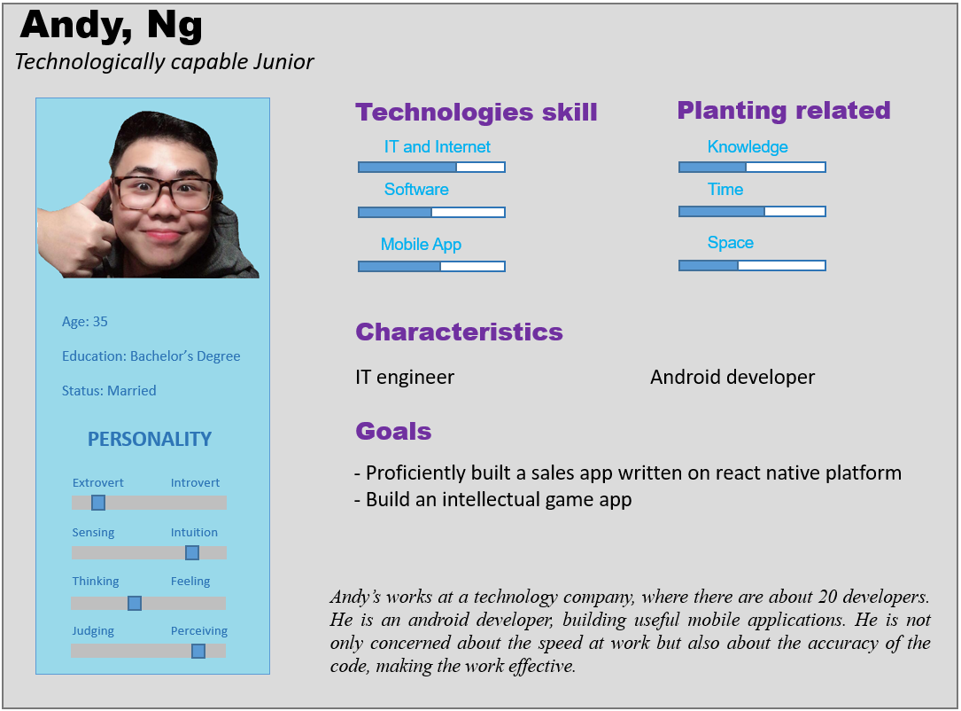

**Scenario1**: Quoc on the occasion of graduation, he wants to travel with friends, and before traveling he wants to buy some clothes. However, Quoc did not know which store sold clothes that were good for him and he decided to go online and choose clothes and pay online. He signs up for that website's account, then selects clothes and pays. In the payment section, there are many options: payment on delivery, payment via ATM card, payment via e-wallet, payment via international cards. Quoc does not have cash available, he chooses to pay via ATM card. He entered the account number, entered the security code and entered the opt-in sequence via the phone. Finally, he can buy clothes and pay online without having to go to the store to buy.

**Sensors:**

* Pay via ATM make the process more and more faster with higher convinience.
* Make people expand the range of choice when buying something/

**Processors:**

* The account number will be checked by the system and then the code will be send.
* The user accept and confirm all the information is correct then allow charging.
* The bill info save into the banking account’s history.

**Output:**

* The system backup all the process for identification in future.

**Scenario2**: Andy goes to a restaurant, he eats with his family. However, he forgot to bring his wallet. The restaurant has many payment options: cash payment, electronic wallet payment, card payment. Andy has an electronic wallet, so he chose this option. He logged into the wallet app in his phone, selected the card he wanted to pay, and entered the password. Thanks to the electronic wallet, Andy has finished the payment.

**Sensors:**

* Pay via e-wallet is a new higher class for better life, people dosen’t need to carry out anything but their smartphone
* Bring a lot of money but they are in a different place, noone can steel it, only you can use it.

**Processors:**

* Money store in bank, then transferto e-wallet
* Buy anything accept pay via e-wallet
* Cashier scan the QR code
* The transaction done
* Bill info sent into the e-wallet application

**Output:**

* The system backup all the process for identification in future.
* Rate or vote for the store, maybe complain